**Angular Pips**

**Use of Pipes**

**Transfer data form, string make k-sensitive, built-in pipes use in HTML file, and built-in pipes do not use in TS file**

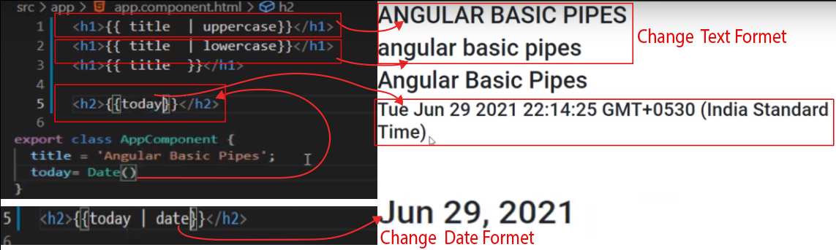

**The problem that can resolve pipes**

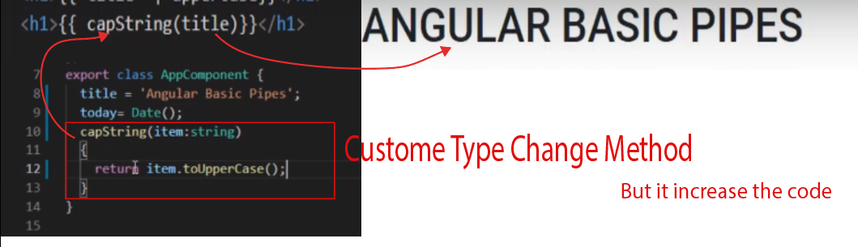

**Pipe List**

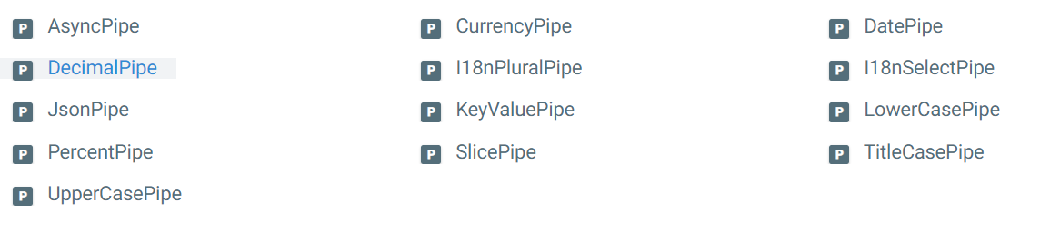

**Params with Pipes**



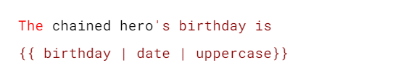

**Use 2 pipes at the same time**

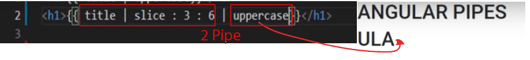

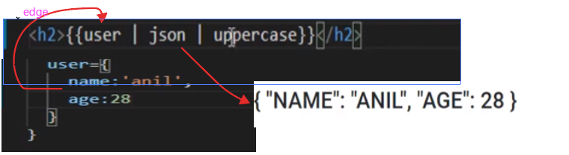

**Number Pipes, Currency Pipes**

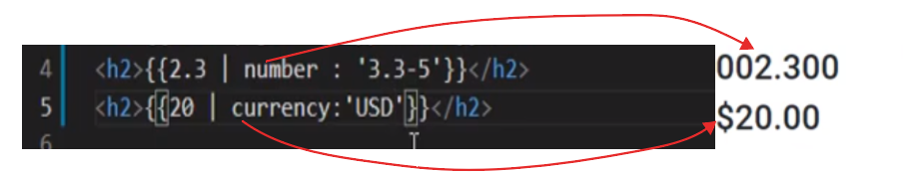

**Custom pipe**

**Custom pipe use in major function or logic**

**Make a Custom pipe with command, Apply custom pipe, Update custom pipe file, params in custom pipes**



